Introduction:
Electric vehicles (EVs) are an innovation in the transportation industry, since they provide a more environmentally friendly and sustainable option than cars with engines that burn gasoline. Electric cars run on energy stored in rechargeable batteries, as opposed to traditional cars, which run on gasoline or diesel fuel. Growing worries about air pollution, climate change, and the limited availability of fossil fuels have contributed to the considerable demand for this technology in recent years. Approximately two million electric vehicles (EVs) are registered in the US as of 2023 (US Department of Energy). However, with the introduction of more advanced EV vehicles and more infrastructure, this number is anticipated to rise (Electric Drive Transportation Association). Government incentives have also promoted the use of electric cars.
The data in our dataset displays the electric vehicles (EVs) that are now registered with the Washington State Department of Licensing, which is responsible for overseeing both driver's licenses and insurance registration. We sourced our dataset from the United States government's open data website. Our database will contain information about EV’s make, which is what company made the vehicle, model, model year, which is the year the vehicle was released, and electric range in miles. Our dataset also contains every vehicle’s identification code, which is dependent on the year model and make of the vehicle. As for information regarding the location, our dataset has the county, city, and zip code for every EV.
It is important that we discuss the various factors that make electric vehicles a better option for our environment today. We chose this topic because we all agree that production of electric vehicles offers a range of environmental, economic, and societal benefits, contributing to a more sustainable and resilient transportation system. Electric vehicles (EVs) have zero exhaust emissions, which lowers greenhouse gas emissions which contribute to climate change. This category is of interest to our group because we would like to understand the enormous impacts that electric vehicles have on the future of our environment and society.

Database Description:

Our team is dedicated to developing a comprehensive database focused on electric vehicles (EVs) registered with the Washington State Department of Licensing. Our goal is to create a user-friendly and informative database for stakeholders interested in EVs, including manufacturers, policymakers, and consumers.
The primary objective of this database is to centralize information about EVs' make, model, model year, electric range in miles, and unique identification code. By compiling this data, we aim to provide insights into the environmental benefits of EVs, including reduced greenhouse gas emissions, lower costs, and increased efficiency.
Additionally, we intend to include location data for each EV, such as county, city, and zip code. This information can help manufacturers plan and prioritize the development of charging infrastructure, strategically placing charging stations in high-EV concentration areas to promote increased EV adoption.
Our database will be a valuable resource for EV manufacturers, enabling them to gain insights into consumer preferences, market trends, and the success of various vehicle models over time. This knowledge can inform decisions on new product development, production planning, and resource allocation, ultimately leading to a competitive advantage in the expanding EV market.
By focusing on relevant and meaningful attributes, our database will provide actionable insights that contribute to the advancement of the electric vehicle industry and promote a more sustainable transportation system.
Logical Design: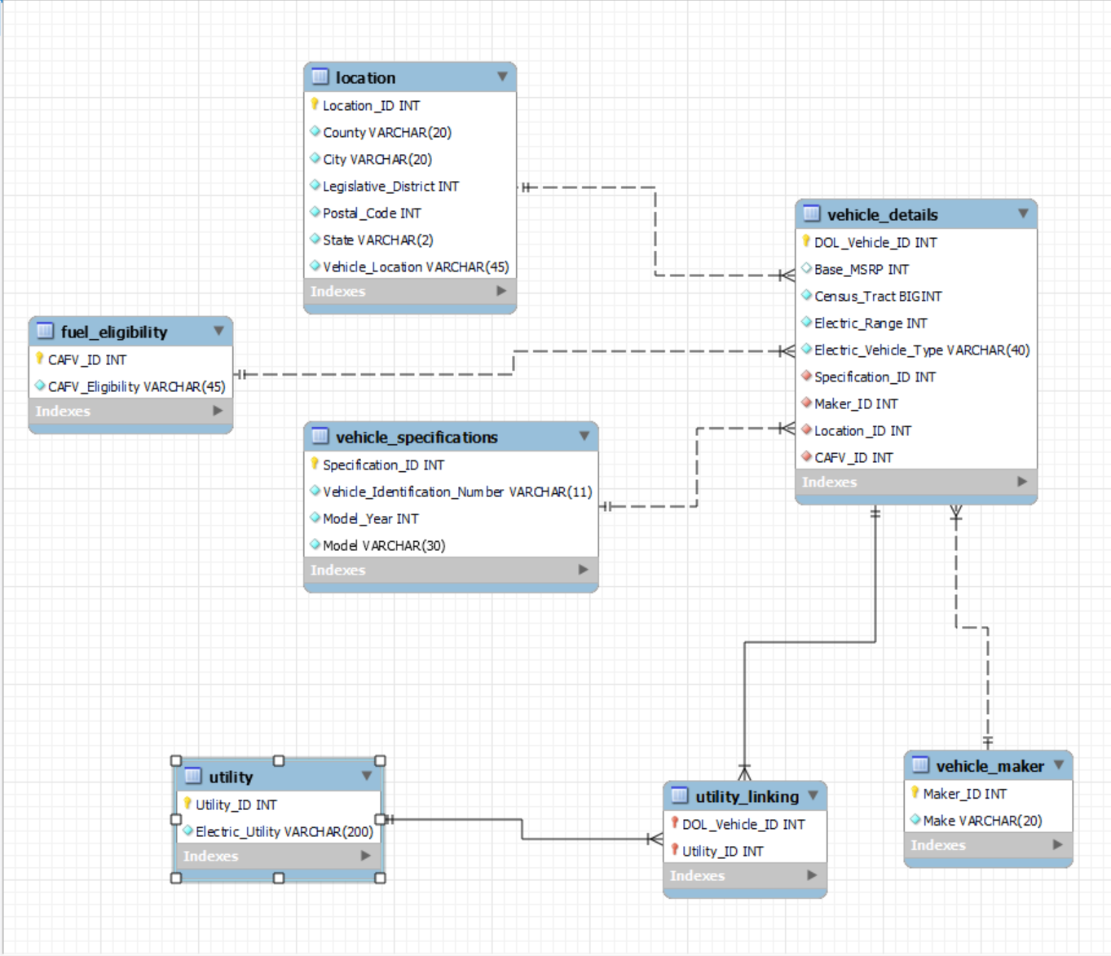
The aim of our database is to organize data in a meaningful way, ensuring its completeness, accuracy, accessibility, and visualization for stakeholders interested in EVs. As a result, we created six tables and one linking table that prioritizes user experience by striking a balance between simplicity and detail. Each table represents a specific aspect of EVs, such as fuel eligibility, location, vehicle details, specifications, utility, and maker. EV tables include information such as base MSRP, electric range, type of vehicle, model year, and maker of the vehicle.
Furthermore, we decided to include a variety of constraints in the database, among them primary keys and foreign keys, to ensure precision and consistency. With this accuracy of information, stakeholders can trust the information and be able to make decisions confidently, as they can use it to facilitate queries and not feel restricted because we ensure that the scope of information is comprehensive so that they can rely on it.

Physical Design:
Electric vehicle (EV) manufacturing companies can benefit greatly from our database in several ways. Manufacturers may learn more about consumer preferences, market trends, and the success of various vehicle models over time by examining EV make, model, and model year, all contained in our database. Decisions on new product development may be made using this knowledge, which enables businesses to improve current models and create new ones that better suit the wants and needs of their target market. Through the use of our database, manufacturers can better plan their production and devote resources by predicting demand for particular vehicle models, given data on EV make and model year.
Understanding where EVs are located can help manufacturers plan and prioritize the development of charging infrastructure. Manufacturers can strategically place charging stations to meet the increasing demand for electric vehicles by identifying high-EV concentration locations. This may help reduce fear of limited range and promote increased EV adoption. This database would also allow consumers to understand the vehicles that they are purchasing by allowing them to understand the benefits and find the best fit for them.
Sample Data:
The main source of our data will be acquired from the Washington state database. The original dataset contains almost 60,000 data entries. Since many of the entries will be unnecessary and overwhelming to the scope of our database, we have decided to only include
around 30 rows of data. Additionally, we plan to reduce any repeated entries of the same model to reduce redundancy and prioritize unique datasets for our database. For example, the original database contains over a thousand rows dedicated to a certain model; however, in our database, we will only include 1–2 rows per car model.
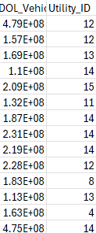
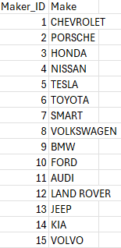
Our sample data will include all the elements mentioned in our ERD. There will be 7 data tables in total. The first table will be for the vehicle_details which will include elements like Vehicle ID, electric vehicle type, base MSRP etc. The second table will be dedicated towards vehicle_specifications, which contain columns such as model and year. Our third table will be for the vehicle’s location which will include the country, city, state and legislative district. The last four tables will be for vehicle manufacturer, fuel eligibility, vehicle utility and utility linking table respectively.
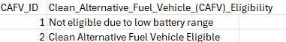

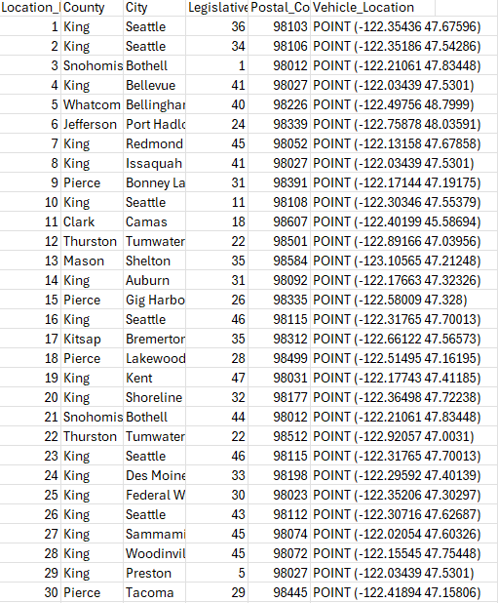

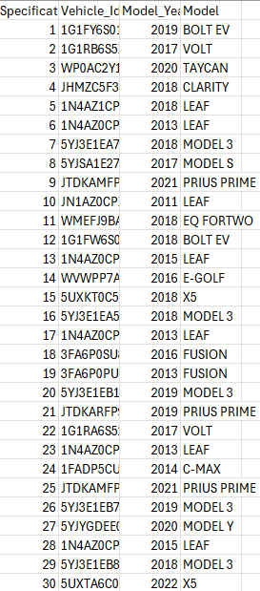
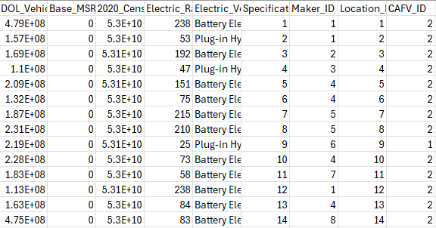

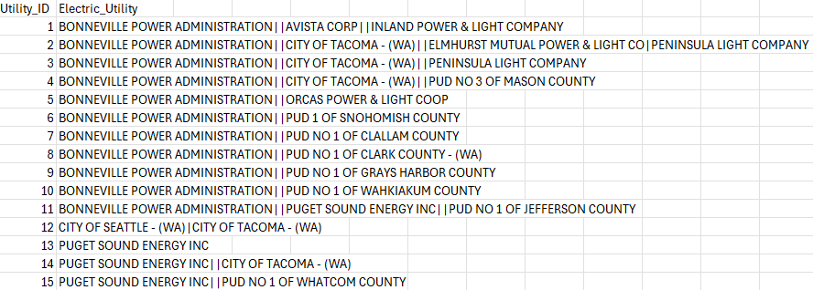

Views and Queries:

 | Join | Filter | Aggregate | Linking(min 1) | Subquerry
New_Teslas_in_King_County | x | x | x |  | x
company_vehicles_eligibility_per_county | x | X
Luis- num_cars&avg_range_seattle | x | x | x
(ev_range_over_100) | x | x | x
Electric_vehicle_based_on_Utility_Company | x | x |  | x | x

The following list describes what each query we wrote for our database displays:
Query 1: Displays the Teslas in King County with the latest manufacturing year.
Query 2: Displays the electric vehicles across the different counties in Washington that are CAFV certified and also the companies that made those vehicles
Query 3: Displays the total number of cars and the average electric range for each type of electric vehicle in Seattle. The SQL query retrieves data about electric vehicles in Seattle, including the type of electric vehicle, the total number of cars for each type, and the average electric range for each type. The data is sourced from the ev_db database, specifically joining tables vehicle_maker, vehicle_details, and location.
Query 4: Creates a view of electric vehicles that have an electric range of more than 100 miles ordered by range.
Query 5: This SQL queries creates a view where it retrieves data about electric vehicles
associated with the utility company "PUGET SOUND ENERGY INC", presenting information about their electric range, vehicle type associated with this utility company. The results are ordered by electric range in descending order.
Database Ethics Considerations:
When it comes to privacy, copyright, fair use, and other ethical considerations, the only real issue that comes to our minds is issues around privacy and other related concerns to privacy. This data set does contain some location data including the vehicle location based on zip code and the city, county, and state the vehicle is located in. Certain elements of this data might be used to identify people who may own this location, especially when it comes to the vehicle location column. That is why we will only be using the county and city columns when creating our views to make it less identifiable who the owner of the vehicle may be. The only other issue around privacy that we can think of besides location is the vehicle identification number, which we may use in some of our views. Certain factors about the VIN can be used to trace the vehicle back to its owner. Though due to the necessity of the VIN in our data design and it already being available on the Washington state government's website, we will still be using this data. Other than that, there are no real copyright issues surrounding the data since it was all collected and posted by a state government for use of that data, and we will not be using any proprietary or private data sources.
We will attempt to ensure the privacy of all users and vehicle owners by attempting to only include information about vehicles owned by the company or dealerships. We would also try to make sure that we are not including any information that could be a legal liability, which could include things like bashing a company or purposefully alerting data in order to make the vehicle seem less efficient. Furthermore, we are dedicated to creating a database that gives general information that we gain about each vehicle rather than allowing for an owner to be identified, so we will steer far from this. Remaining ethical throughout this project is our main priority, so we will do our best to ensure data privacy, respect fair use laws, and stick to all ethical considerations necessary.
Changes from Original Design:
Following the initial project phase, we made a strategic decision to improve our ERD table by merging the attributes of the “Owner location” table with the “Location” table to optimize data quality. We made this adjustment to introduce “Fuel Eligibility” as our new table. The columns of the utility table have been compressed from two to one. In contrast to these major changes, we also made some slight modifications to some of the other tables in respect to the original design, which simplified and visually improved our ERD diagram for the users to understand. While the scope of our tables has been redefined, the core entities and their associated attributes also changed as they continue to accurately represent the data intended for inclusion. The initial project proposal established a comprehensive attribute set, eliminating the need for additional attributes beyond primary and foreign keys. We added new primary keys and foreign keys for the new and merged tables as suggested by our mentor. The changes were addressed for future queries where users might have to join tables to get specific data.
Following the progress report, we revised our ERD, suggested by our mentor. We changed all the variable names by removing all the spaces and replacing them with “_” in order to make our CRUD queries run more smoothly. We also changed some of the names of the Primary keys to match the Foreign keys in order to avoid any issues with linking the tables together. After making these revisions to our ERD, we were successfully able to forward engineer our database and add the data from the CSV file. While attempting to import the data from the CSV files, we ran into a few issues. One issue was that a few of our variable types were not large enough to hold the data that was being imported from the CSV file. This issue was easily repairable by just changing the data type value for the necessary fields. This was the only noteworthy issue.
Lessons Learned:
One of the biggest lessons we learned from this week was time management. We learned that to complete this project both on time and the best matter as possible, we would need to learn how to manage our time wisely to make sure that we were both spending enough time on this project and making sure we had time to do other work outside of class. Basically, just learning how to delegate and budget time to both have time to complete this project and do other things besides the project and outside of class. Another important lesson we learned from this project was how important communication is when working with a team. Our team always tried to communicate and plan before completing certain assignments for the project. Our team always tried to discuss and communicate with every team member on what parts of the project each would be completing and when we needed it done by. So, we learned that communicating who does what on the project and when they should get it done and possibly how they would do it was very important in getting project assignments out on time and as extensive as possible. Lastly, we learned that delegation is key when working as a team. When we first started working out we tried to do each part of a team all together, but we soon learned that it was much easier to just split up the work between individual group members and that splitting it up would allow for us to both finish the assignment faster and get more content into the different sections of the project that we were working on. So basically we learned that splitting up the work of different sections to different people allowed us to get work done in a more efficient manner, but we also had to communicate with each other to let others know exactly what our different sections talked about, which is where communication was important.
Potential Future Work:
One of the potential ways we could work on this dataset and data in the future is to try and expand the amount of data that we are collecting for the dataset. We could possibly add certain more details such as average cost to help determine other factors that might make certain electric vehicles more desirable. We could also try to expand the collection of the data from outside the state of Washington, since that is the only state where data is being collected at the moment. This type of expansion might allow us to grow our knowledge of what cars may be more popular in other parts of the country. Lastly, we may be able to create more views, such as looking more into specific areas such as cities to see which were more likely to purchase electric vehicles. This would help us find out certain trends on what electric vehicles people are buying. This could better help us determine what makes people more likely to buy certain electric vehicles over others and what specific areas may purchase more electric vehicles than others, and so companies can better find audiences that may be more likely to buy their electric vehicles.

Citations: MLA 8th ed.

Work Cited
Washington State Open Data. “Electric Vehicle Population Data | Data.WA | State of Washington.” data.wa.gov, https://data.wa.gov/Transportation/Electric-Vehicle-Population-Data/f6w7-q2d2/about_data. Accessed 18 April 2024.
Electric Drive Transportation Association. “EDTA.” electricdrive.org, 2021, https://electricdrive.org/ht/d/sp/i/68516/pid/68516. Accessed 24 February 2024.
US Department of Energy. “Alternative Fuels Data Center: Maps and Data.” Alternative Fuels Data Center, July 2023, https://afdc.energy.gov/data/10962. Accessed 24 February 2024.

